

Control Tower System Analysis

Table of Contents

Introduction and Working Hypotheses 1

System Description 1

System Behaviour 1

Working Hypotheses 1

System Modelling 2

Queuing Theory Model (attempt) 2

Simulation Model 3

Preliminary Analyses 4

System Stability Study 4

Subsampling and Confidence Level 5

Warm-up Time Study 6

Statistics Distributions Fitting 6

2kr Factorial Analysis 8

System Fairness Analysis 10

Concluding Remarks 12

Introduction and Working Hypotheses

System Description

The system under analysis consists in an airport with a single runway, which can be used by one airplane at a time for landing or take-off operations, a parking area, where airplanes are temporarily stationed between landing and take-off, and a control tower, which routes the air traffic within the airport.

System Behaviour

The system behaviour can be described as follows:

1. Airplanes intending to land reach the airport with an interarrival time “tA”.
2. Whenever an airplane intending to land reaches the airport, it enqueues for landing waiting for the authorization from the control tower.
3. As soon as authorized by the control tower, the airplane performs the landing operation occupying the runway, which completes in a time “tL”.
4. As soon as the airplane has finished landing it frees the runway and moves towards the parking area, where it will remain stationed for a time “tP”.
5. When the airplane finishes its parking time, it enqueues for take-off, again waiting for the authorization from the control tower.
6. As soon as authorized by the control tower, the airplane performs the take-off operation, occupying the runway, which completes in a time “tO”.
7. When the airplane completes the take-off operation, it leaves the system.

From here the control tower routes the traffic within the airport by authorizing the landing or take-off of the airplane having waited the longest to use the runway, assigning it to the next longest waiter as soon as the airplane completes its landing or take-off.

Working Hypotheses

The system must be analysed under the following given hypothesis:

1. The system must be analysed supposing the “tA” , “tL”, “tP” and “tO” times described above both as constants (deterministic regime) and as rates of exponential random variables (stochastic regime).
2. The airplanes awaiting landing have an infinite fuel supply, meaning that they can wait for an infinite time without the risk of crashing.
3. The parking area has an infinite airplane capacity.

The system analysis will also be based on the following additional hypotheses:

1. The system will be analysed starting from an empty state, meaning that there are no airplanes parked, landing or taking off, and where the first airplane will reach the system in a time “tA”.
2. The airplanes parking time “tP” starts as soon as they leave the runway, and comprises the time required to reach the parking facilities, to perform any passengers/cargo unloading/loading and refuelling, and to leave the parking facilities reaching a separate area adjacent to the runway, where they will wait for the authorization to take-off from the control tower. Following this description, the total number of grounded planes within the airport is given by the number of parked airplanes plus the number of airplanes enqueued for take-off.
3. Should two airplanes be ready for landing and take-off at exactly the same time (which may occur both in deterministic and stochastic regimes, in the latter case due to quantization roundings), the Control Tower will assign the runway to the airplane requesting to land.
4. The system time evolution strictly attunes to the behaviour described above, where real case delays such as the ones determined by the communications between the airplanes and the control tower, the ignition time of the engines prior to take-off, or the local spatial displacements of the airplanes awaiting landing or take-off are not taken into account.

System Modelling

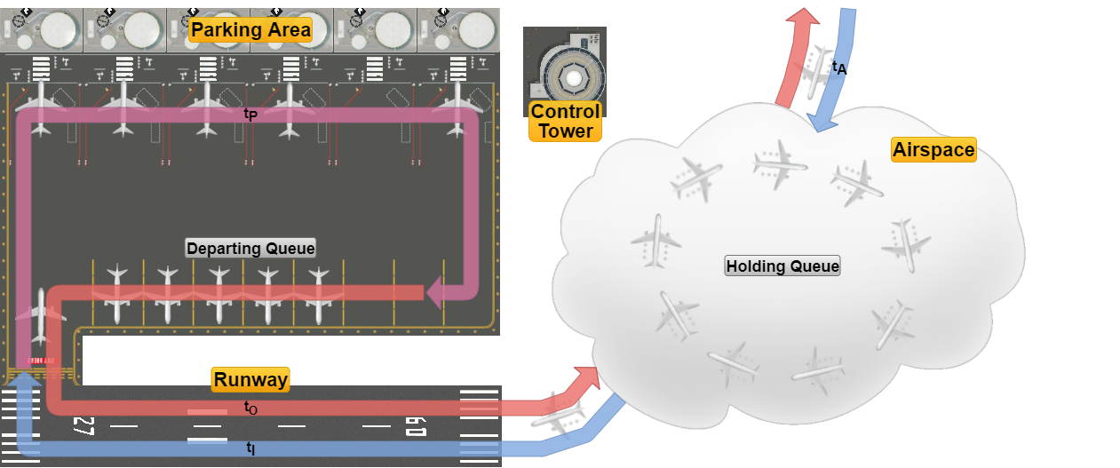

The system can be functionally divided into the following components:

* The *Airspace* surrounding the airport, where the airplanes intending to land arrive with an interarrival time “tA” and enqueue for landing in the *Holding Queue*, and where airplanes transit once they have taken off, leaving the system.
* The *Runway*, which is used mutually exclusively by airplanes for landing and take-off operations, which are performed in times “tL” and “tO” respectively.
* The *Parking Area*, which consists of the facilities where the airplanes transit through after they have landed and before they are ready for take-off, which occurs in a time “tP”, after which the airplanes enqueue in a separate *Departing Queue* adjacent to the runway waiting for the authorization to take-off.
* The *Control Tower*, which acts as a logical entity routing the traffic within the airport.

Queuing Theory Model (attempt)

The system can be tentatively described in terms of queuing theory as a classed routing network with the jobs representing airplanes divided into the two classes as follows:

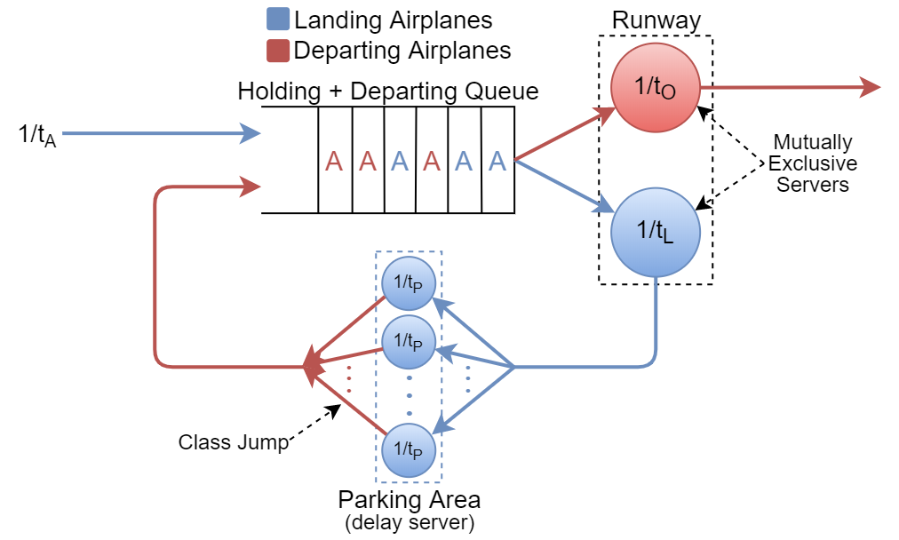

Where:

* The *Holding* and *Departing* *Queues* have been logically merged into a single virtual queue having as server the *Runway*, which in turn is divided into two logical servers with service rates ““ and ““ relative respectively to the landing and departing classes, servers whose services are mutually exclusive (i.e. just one airplane at a time can be served in the runway by the virtual server associated with its class).
* The *Parking Area* represents a *Delay Server* with service rate “”, which also switches the airplanes from the Landing to the Departing class.

It should also be noted that, representing a Delay Server, the *Parking Area*’s parking time “tP” will have no effect on the system’s stability, as is thoroughly discussed later in the document.

* The *Control Tower*, being a logical entity, finds no correspondence in the model.

From here, since we are unable to determine the steady-state equations of the network and thus its performance metrics, in order to analyse the system the use of a simulation software is required.

Simulation Model

The simulator software used is OMNeT++ 5.5.1, wherein the system model was reproduced as follows:

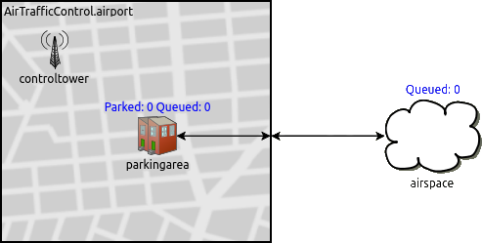

Where:

* The *airspace*, the *parkingarea* and the *controltower* represent simple modules, the last two being logically grouped inside an *airport* compound module representing the airport grounds.
* The *runway* represents the connection between the *parkingarea* (and the *airport* module) and the *airspace*.
* The *controltower* acts again as a logical module that doesn’t exchange messages (i.e. airplanes) with the others, and being the communication delays between the tower and the airplanes not taken into account (hypothesis 6.), the synchronizations between the landing/departing airplanes and the control tower are performed via cross-module calls, where each time a landing/take-off is completed the control tower assigns the runway to the airplane with the longest waiting time in the *Holding Queue* (*airspace*) and the *Departing Queue* (*parkingarea*).

The results that follow were obtained through the sampling of the following quantities during the system time evolution:

* The number of airplanes waiting in both queues (*Holding Queue Size* and *Depart Queue Size*).
* The airplanes’ waiting times in both queues (*Holding Queue Waiting Time* and *Depart Queue Waiting Time*).
* The number of parked airplanes (*Parked Planes*).
* The system total response time (*Airport Response Time*).

Preliminary Analyses

System Stability Study

Following our tests, we determined the stability condition of the system to be:

tA > tL + tO

Which expressed in terms of interarrival rate and service rates and becomes:

Meaning that the overall system presents an equivalent service rate of:[1]

Moreover, the utilization factor of the system is given by:

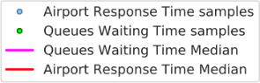As an empirical confirmation of such results, below are shown instances of the trends, both in deterministic and exponential regimes and in stable and unstable conditions, of the *Airport Response Time* and the *Queues Waiting Times* statistics (the latter representing the joint trend of the *Holding Queue Waiting Time* and the *Depart Queue Waiting Time*, which will be proven later to share the same behaviour in the system).

|  |  |  |
| --- | --- | --- |
| **Instability**  tA < tL + tO | **Deterministic Regime** | **Exponential Regime** |
| **Stability**  tA > tL + tO |  |  |

Where we can observe that:

* If tA < tL + tO both statistics diverge as the sample width increases, compelling evidence of an unstable system.
* In deterministic regime if tA > tL + tO the statistics do not diverge and fluctuate around their mean values, oscillations that could be demonstrated to collapse on their means should tA > tL + tP + tO, a situation in which the entire system is occupied by a single airplane at a time.
* In exponential regime if tA > tL + tO the statistics do not diverge and we can observe them to be strongly correlated, both with themselves (*autocorrelation*) and with the other.

Subsampling and Confidence Level

As is outlined in the plots above, all the samples of the system statistics (with the exception of the *Parked Planes*) present a strong degree of autocorrelation, thus, in order to allow us to properly define the degree of confidence of the results of our further analyses, an iterative subsampling process was applied to each statistic dataset, to ensure the IID-ness of the samples and thus derive from the initial sample width “N” the effective sample width “Neff“ that will be used in the computation of our confidence intervals, which will be taken with a confidence level of 95% (α = 0.05).

The iterative subsampling process used is described in the pseudo-code below:



Where the IID-ness of the samples in each dataset was tested by checking that all sample autocorrelation coefficients have an absolute value of less than the ±zα/2/√N for each possible lag.

We also noticed the degree of autocorrelation in the datasets to be directly affected by the system utilization factor ρ, with higher values of the latter causing higher degrees of autocorrelation, thus lowering the resulting effective sample widths “Neff” given the same initial sample widths “N”, as is shown in the trend instances below:

|  |  |  |
| --- | --- | --- |
| **Low Utilization (ρ = 0.33)** | **Before Subsampling**    N = 100.000 | **After Subsampling**  NEFF = 164 |
| **High Utilization (ρ = 0.75)** | N = 100.000 | NEFF = 111 |

Warm-up Time Study

From our analyses and referring to the equivalent QT model we concluded that the system’s warm-up time corresponds to the time required by the mean throughput of airplanes on the feedback loop, represented by the parking area, to stabilize, which depends with different weights on all the system parameters (tA, tL , tP, and tO).

Deterministic Warm-up Time

In deterministic regime we deduced the system’s warm-up time to coincide with the time the first airplane finishes its parking time and enqueues in the *Departing Queue*, which occurs at the time:

tWARM-UP = tA + tL + tP

Furthermore at this instant, under the stability condition, since no airplane has yet taken off from the airport, the “transient” contribution of the departing service time “tO“ to the overall service time will be null, from which, by considering the stability condition:

tA > tL + tO ⇒ tA > tL ⇒ λA < µL

Which allows us to assert that in deterministic regime at the warm-up time tWARM-UP = tA + tL + tP, with the only exception of an airplane enqueuing in the *Holding Que*ue at the same instant, such queue will be empty, one airplane might be landing, and thus the first airplane exiting the parking area will be the next to use the runway for take-off.

Exponential Warm-up Time

In exponential regime, due to the randomness of the system parameters, the previous results are invalid, and although we tested some empirical formulas in an attempt to estimate the warm-up time as the sum of the parameters’ mean values multiplied by a constant, such as:

tWARM-UP = k(tA + tL + tP + tO) k ∈ ℕ

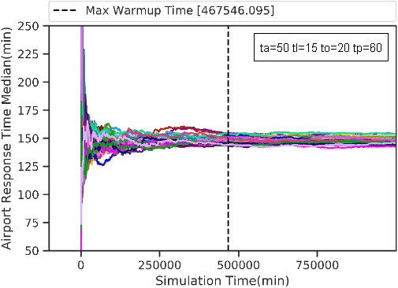due to inconsistencies in the results we finally settled on selecting the warm-up time in exponential regime using a more rigorous approach where, considering the *Airport Response Time* as the most comprehensive statistic in our system and by using N=100 different RNG seeds, for each given configuration tA, tL, tP, and tO we selected the warm-up time as the maximum time at which the ART samples differ from their mean value by less than two orders of magnitude of their standard deviation for a consecutive number of samples, where an example of computation is depicted in the plot at right:

Statistics Distributions Fitting

The next step in our analysis consisted, in exponential regime and under the stability condition, in determining the distribution families the statistics in our system belong to, fitting whose results are shown in the QQ-plots below:

|  |  |  |
| --- | --- | --- |
| **Holding Queue Size**  Geometric Distribution | **Depart Queue Size**  Geometric Distribution | **Parked Planes**  Poisson Distribution |
| **Holding Queue Waiting Time**  Exponential Distribution | **Depart Queue Waiting Time**   Exponential Distribution | **Airport Response Time**  Hypoexponential Distrib. |

Once the distributions were fitted, to better understand their relationships, we also attempted to estimate their parameters for a particular configuration through the use of their **Maximum Likelihood Estimator (MLE)[2]**, as shown below:

|  |  |  |
| --- | --- | --- |
| Statistic | Distribution | Maximum Likelihood Estimator |
| Holding Queue Size  Depart Queue Size | Geometric |  |
| Holding Queue Waiting Time  Depart Queue Waiting Time | Exponential |  |
| Parked Planes | Poisson |  |
| Airport Response Time | Hypoexponential |  |

|  |  |
| --- | --- |
|  |  |

|  |  |  |
| --- | --- | --- |
| **Holding Queue Size** | **Depart Queue Size** | **Parked Planes** |
| **Holding Queue Waiting Time** | **Depart Queue Waiting Time** | **Airport Response Time** |

Where the main observation that can be derived from the values of the parameters is that the *Holding Queue Size* and the *Depart Queue Size*, as well as the *Holding Queue Waiting Time* and the *Depart Queue Waiting Time*, present the same distributions with approximately the same values, additional evidence that both queues behave as a single logical queue as predicted in the system equivalent QT model.

2kr Factorial Analysis

Next, to better understand the contributions of the parameters tA ,tL, tP and tO, we performed a 2kr factorial analysis using 500 replications for each configuration, for a total of 24*500 = 8000 simulations, whose results are shown below (where the combinations of parameters having a null contribution for a statistic have been omitted for clarity):

Holding Queue Size (HQS)

|  |  |  |  |  |  |  |  |  |  |  |
| --- | --- | --- | --- | --- | --- | --- | --- | --- | --- | --- |
|  | MP | tA | tL | tA tL | tO | tA tO | tL tO | tA tL tO | tP | other |
| **q** | 0.841 | -0.412 | 0.361 | -0.244 | 0.342 | -0.23 | 0.153 | -0.145 | 0.0008 | … |
| **SS** | 5.66e3 | 1.36e3 | 1.03e3 | 4.76e2 | 9.36e2 | 4.22e2 | 1.87e2 | 1.68e2 | 0.0056 | … |
| **Impact** | - | **29.58%** | **22.67%** | **10.37%** | **20.41%** | 9.19% | 4.09% | 3.67% | 0.00% | 0.00% |
| SST = 4.59*103 | | | | SSE = 0.901 | | | SSE/SST = 0.02% | | | |

Depart Queue Size (DQS)

|  |  |  |  |  |  |  |  |  |  |  |
| --- | --- | --- | --- | --- | --- | --- | --- | --- | --- | --- |
|  | MP | tA | tL | tA tL | tO | tA tO | tL tO | tA tL tO | tP | other |
| **q** | 0.829 | -0.408 | 0.391 | -0.255 | 0.312 | -0.218 | 0.165 | -0.149 | 0.0015 | … |
| **SS** | 5.5e3 | 1.33e3 | 1.22e3 | 5.2e2 | 7.77e2 | 3.82e2 | 2.18e2 | 1.78e2 | 0.018 | … |
| **Impact** | - | **28.73%** | **26.42%** | **11.24%** | **16.78%** | 8.25% | 4.71% | 3.84% | 0.00% | 0.00% |
| SST = 4.63*103 | | | | SSE = 0.905 | | | SSE/SST = 0.02% | | | |

Holding Queue Waiting Time (HQWT)

|  |  |  |  |  |  |  |  |  |  |  |
| --- | --- | --- | --- | --- | --- | --- | --- | --- | --- | --- |
|  | MP | tA | tL | tA tL | tO | tA tO | tL tO | tA tL tO | tP | other |
| **q** | 29.4 | -17.0 | 18.3 | -12.5 | 17.4 | -11.9 | 9.99 | -8.58 | 0.0427 | … |
| **SS** | 6.91e6 | 2.32e6 | 2.67e6 | 1.25e6 | 2.41e6 | 1.13e6 | 7.98e5 | 5.89e5 | 14.6 | … |
| **Impact** | - | **20.81%** | **23.91%** | 11.20% | **21.56%** | 10.09% | 7.14% | 5.27% | 0.00% | 0.00% |
| SST = 1.12*107 | | | | SSE = 2.25*103 | | | SSE/SST = 0.02% | | | |

Depart Queue Waiting Time (DQWT)

|  |  |  |  |  |  |  |  |  |  |  |
| --- | --- | --- | --- | --- | --- | --- | --- | --- | --- | --- |
|  | MP | tA | tL | tA tL | tO | tA tO | tL tO | tA tL tO | tP | other |
| **q** | 29.1 | -17.0 | 19.0 | -12.8 | 16.7 | -11.6 | 10.3 | -8.67 | 0.0791 | … |
| **SS** | 6.76e6 | 2.3e6 | 2.88e6 | 1.3e6 | 2.22e6 | 1.08e6 | 4.49e5 | 6.02e5 | 50.1 | … |
| **Impact** | - | **20.47%** | **25.60%** | 11.60% | **19.79%** | 9.60% | 7.55% | 5.36% | 0.00% | 0.00% |
| SST = 1.12*107 | | | | SSE = 2.25*103 | | | SSE/SST = 0.02% | | | |

Parked Planes (PP)

|  |  |  |  |  |  |  |  |  |  |  |
| --- | --- | --- | --- | --- | --- | --- | --- | --- | --- | --- |
|  | MP | tA | tL | tA tL | tO | tA tO | tL tO | tP | tA tP | other |
| **q** | 1.71 | -0.303 | -0.015 | 0.0079 | 0.0149 | -0.0079 | -0.0069 | 0.399 | -0.0997 | … |
| **SS** | 2.33e4 | 7.37e2 | 1.79 | 0.51 | 1.77 | 0.503 | 0.376 | 1.28e3 | 79.5 | … |
| **Impact** | - | **35.15%** | 0.09% | 0.02% | 0.08% | 0.02% | 0.02% | **60.82%** | 3.79% | 0.00% |
| SST = 2.1*103 | | | | SSE = 0.0373 | | | SSE/SST = 0.00% | | | |

Airport Response Time (ART)

|  |  |  |  |  |  |  |  |  |  |  |
| --- | --- | --- | --- | --- | --- | --- | --- | --- | --- | --- |
|  | MP | tA | tL | tA tL | tO | tA tO | tL tO | tA tL tO | tP | other |
| **q** | 1.83e2 | -34.0 | 44.7 | -25.3 | 41.5 | -23.5 | 20.3 | -17.3 | 30.1 | … |
| **SS** | 2.69e8 | 9.25e6 | 1.6e7 | 5.11e6 | 1.38e7 | 4.41e6 | 3.29e6 | 2.38e6 | 7.26e6 | … |
| **Impact** | - | **15.04%** | **26.02%** | 8.31% | **22.42%** | 7.17% | 5.35% | 3.87% | **11.8%** | 0.00% |
| SST = 6.15*107 | | | | SSE = 9.2*103 | | | SSE/SST = 0.01% | | | |

From here, before computing the confidence intervals of our results, we have checked the residuals to be normally distributed with a null mean and a constant standard deviation, a hypothesis which is verified exclusively for the *Parked Planes*, as shown below:

|  |  |
| --- | --- |
| **Parked Planes Residuals Analysis** | |
| **Residuals QQ-Plot** | **Residuals vs Predicted Response** |

Where the lack of any discernible trend in the plot of the residuals against the predicted response (the former also being more than one order of magnitude less than the latter) allows us to compute the following confidence intervals of the results relative to the *Parked Planes*:

Parked Planes (confidence intervals)

|  |  |  |  |  |  |  |  |  |  |
| --- | --- | --- | --- | --- | --- | --- | --- | --- | --- |
|  | MP | tA | tL | tA tL | tO | tA tO | tL tO | tP | tA tP |
| **q** | 1.71 | -0.303 | -0.015 | 0.0079 | 0.0149 | -0.0079 | -0.0069 | 0.399 | -0.0997 |
| **CI** | (1.71,  1.71) | (-0.304,  -0.303) | (-0.015,  -0.0149) | (0.00794,  0.00803) | (0.0148,  0.0149) | (-0.00798,  -0.00788) | (-0.0069,  -0.0068) | (0.399,  0.399) | (-0.0997,  -0.00996) |

As for the other statistics, while their residuals being not normally distributed prevents us from computing the confidence intervals of their results, they do not undermine their validity, having the errors a very low standard deviation and skewness as well as a mean value more than one order of magnitude less than the mean values of the observed quantities, as summarized in the table below:

|  |  |  |  |  |  |  |
| --- | --- | --- | --- | --- | --- | --- |
|  | Holding Queue Size | Depart Queue Size | Holding Queue Waiting Time | Depart Queue Waiting Time | Parked Planes | Airport Response Time |
| **Mean** | -1.7766e-18 | 7.5939e-17 | 1.5916e-15 | -1.0374e15 | 1.65e-16 | -1.3898e-14 |
| **Std. Dev.** | 0.0106 | 0.0106 | 0.5299 | 0.53 | 0.0022 | 1.0722 |
| **Skewness** | -0.1055 | -0.1245 | -0.135 | -0.1688 | -0.0572 | -0.139 |
| **Min** | -0.0955 | -0.095 | -4.9187 | -4.793 | -0.0116 | -9.773 |
| **Max** | 0.0836 | 0.0809 | 4.2121 | 4.0917 | 0.011 | 8.3428 |
| **25th perc.** | -0.0012 | -0.0012 | -0.0416 | -0.039 | -0.0012 | -0.1263 |
| **Median** | -2.6484e-5 | -3.6922e-6 | 0.0002 | -0.0001 | 1.647e-5 | 0.0015 |
| **75th perc.** | 0.0012 | 0.0013 | 0.043 | 0.04 | 0.0013 | 0.1294 |

In conclusion, the main insights that can be derived from the 2kr analysis are:

* Most of the system statistics are affected, with different weights, only by the parameters involved in the stability condition (tA, tL and tO), while tP only affects the *Parked Planes* and, to a lesser degree, the *Airport Response Time*.
* The *Parked Planes* statistic is affected almost exclusively by the tP and tA parameters.

To better understand this last result, we further analysed the *Parked Planes* trend by varying the ratio between tP and tA, as depicted in the plots below:

|  |  |
| --- | --- |
| **Parked Planes** | **Fitting** |

Which allows us to conclude that in both regimes the average number of *Parked Planes* in the system is given by:

System Fairness Analysis

From the analysis of their trends we observed all the system statistics (except for the *Parked Planes*) to be strongly correlated, where localized delays or advances at any point of the parameters tA ,tL, tP and tO propagate affecting all system statistics, leading to shared trends with alternating spikes of high and dips of low values, indicative respectively of a congested and an almost-empty system.  
Aiming at better understanding this phenomenon we carried out an analysis on the system statistics’ *fairness*, which in general is affected by the three following factors:

1. The system’s utilization factor ρ.
2. The system parking time tP, whose added delay tends to decouple the localized behaviours of the two queues.
3. The relative impacts on each statistic of the parameters tA ,tL, tP and tO and their *likeliness*, where the more a statistic is affected by multiple parameters with comparable weights, the greater its fairness, a behaviour that finds an explanation as a growing manifestation of the *Central Limit Theorem* (CLT), whereas the number and likeliness of influencing RVs increases, so their overall contribution will tend to a normal distribution, which presents a natural higher level of fairness with respect to an exponential distribution.

Queues Waiting Time Fairness

The fairness in the queues waiting time is of relevance for the system users and customers (such as the passengers and the air companies), and since we have already proven the two queues in the system to behave as a single logical queue, their fairness was analysed considering a single queue, whose results in terms of Lorenz Curve Gap (LCG) by varying the system parameters and utilization factor are shown below:

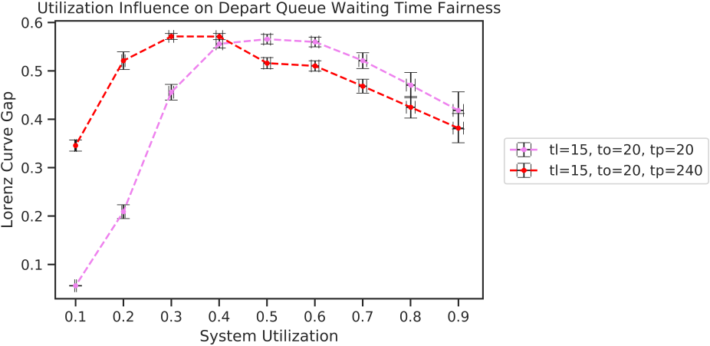

Where we can observe that:

* In both configurations the fairness decreases as the utilization factor increases, up to a threshold of ρ ≈ 0.4 where the trends reverse, leading to a higher fairness at growing utilization levels.  
  This behaviour can be explained with the fact that up to a certain utilization factor “ρj“ the probabilities of airplanes finding the queues in a congested or an almost-empty state are balanced, leading to a lower fairness, while beyond such threshold most airplanes will experience congested queues, thus increasing the fairness.
* At low utilization factors the second configuration with higher parking time tP presents a lower degree of fairness than the first configuration with comparable parameters, a situation that again reverses beyond the threshold of ρj ≈ 0.4 due to the decoupling effect of the parking time on the queues in a congested system.

Airport Response Time Fairness

The fairness of the overall system response time is of relevance for the airport management, and its analysis by varying the system parameters and utilization factor is shown below:

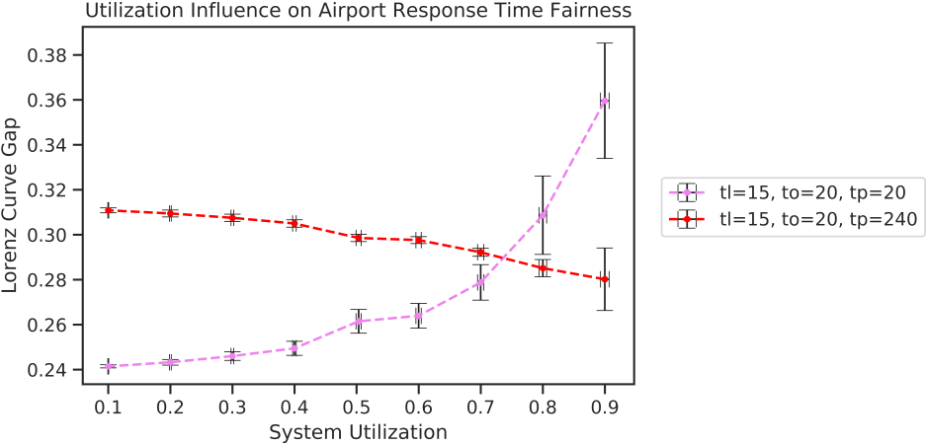

Where in this case we have that:

* In the first configuration with comparable parameters the fairness decreases as the utilization increases, which led us to conclude, since we’ve already proven the queues waiting times fairness to decrease for utilizations ρ > 0.4, that the fairness of the single queues is not directly tied to the fairness of the overall system response time, an observation that we have also confirmed by plotting the ECDF of the sum of the airplanes waiting time in both queues, where as shown the overall fairness decreases as the utilization increases:

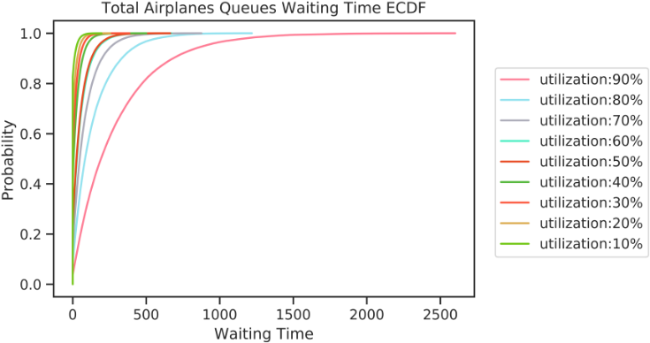

* The second configuration with a with a higher tP presents a different trend with a fairness increasing with the utilization, which can be explained with the decoupling effect of the parking time overruling the combined unfairness of the waiting times in the two queues discussed previously.

Concluding Remarks

As a summary of our analyses we can conclude the examined system to be *unfair by nature*, with trends alternating in time spikes of high and dips of low values, a behaviour that can be mainly attributed to the mutually exclusive utilization of a single shared resource (the *runway*) by the two queues.

Following are some proposals for improving the system performance and possibly its fairness, their application and analysis being outside of the scope of this paper:

1. Introduce additional runways, which as we briefly verified allow for a linear scaling of the system’s equivalent service rate as follows:

N = Number of  
 Runways

1. In a real-world scenario, all necessary measures should be taken in order to limit as much as possible the *randomness* of the system parameters tA ,tL, tP and tO, which in real airports is addressed by the scheduling of flights and the enforcement of strict timing protocols in all the procedures airplanes undergo while in transit.

1. A mathematical analogy of the expression of the equivalent service rate can be found in electric networks theory as the equivalent conductance of the parallel of two conductances
2. Introduction to Probability and Statistics for Engineers and Scientists – S. M. Ross